Hurley Reformed Church
Nineteenth Sunday after Pentecost
October 3, 2021, 10:00 a.m.
Rev. William Appleyard-Pekich, Pastor
Jane Barsumian, Organist and Choir Director
MORNING WORSHIP

OUR APPROACH TO GOD

PRELUDE
WELCOME/ANNOUNCEMENTS/GREETING ONE ANOTHER
CALL TO WORSHIP
Leader: Great and marvelous are your deeds, Lord God Almighty!
All: Just and true are your ways, King of the ages.
Leader: Who will not fear you, O Lord, and bring glory to your name?
All: For you alone are holy. All nations will come and worship you!

*HYMN OF APPROACH: #678, “In Christ is no East or West”
PRAYER OF CONFESSION
Holy Lord, we come seeking forgiveness for the sins which we have committed by our actions and our inaction. These sins burden us and at times overwhelm us. We also must confess that while we seek your forgiveness we have struggled to forgive and to love others. Forgive us Lord, but also help us to forgive one another and ourselves. In your name we pray, Amen.

KYRIE ELEISON [Words and music found on the inside cover of hymnal.]

ASSURANCE OF FORGIVENESS AND SUMMARY OF GOD’S LAW

*RESPONSIVE READING: The Apostle’s Creed
I believe in God, the Father almighty,
maker of heaven and earth;
And in Jesus Christ, his only Son, our Lord;
who was conceived by the Holy Ghost,
born of the Virgin Mary,
suffered under Pontius Pilate,
was crucified, dead, and buried.
He descended into hell.
The third day he rose again from the dead.
He ascended into heaven,
and sitteth on the right hand of God the Father almighty.
From thence he shall come to judge the quick and the dead.
I believe in the Holy Ghost,
the holy catholic Church,
the communion of saints,
the forgiveness of sins,
the resurrection of the body,
and the life everlasting. Amen.
*GLORIA PATRI [Words and music found on inside cover of hymnal.]

CHILDREN’S MESSAGE

THE WORD OF GOD
*HYMN OF PREPARATION: #737, “All Things Bright and Beautiful”

SCRIPTURE LESSONS:
Old Testament: Lamentations 1:1-6
New Testament: Matthew 25:31-46

SERMON: “I was and You did”

OUR RESPONSE TO GOD
OFFERING
*DOXOLOGY [Words and music found on inside cover of hymnal.]
PRAYER OF DEDICATION (unison)

MORNING PRAYER
THE LORD’S PRAYER (debt/debtors)

SACRAMENT OF THE LORD’S SUPPER

THANKSGIVING AFTER COMMUNION

*HYMN OF CONSECRATION: #20, “Praise to the Lord”
*BENEDICTION
*POSTLUDE

*Please stand if you are able
Welcome to Hurley Reformed Church!
With joy we welcome your presence among us today. Let the words of the psalmist set the tone of our worship: “Sing praises to the LORD, O you faithful ones, and give thanks to his holy name . . . joy comes with the morning” (Psalm 30:4-5 NSRV)
Flower on the Alter are provided by The Croswell’s
Ushers assisting in the service are Glenn Decker and Tom Harkin.
In Person and Zoom Worship happens at 10am!
Please join us in Schadewald Hall after worship for coffee and snacks! Thank you to Marilyn Lowe for providing this refreshment!
Reach out to those who need your support in their day to day needs:
Judy Bell (Terry Gaffken’s mom) needs prayers; Viola Opdahl is home; Shirley Ruth is in Golden Hill; Alice Presti has moved to North Carolina nearer her daughter; Bev Roosa is at the Terraces at Brookmeade; Fred Horvers is at TenBroeck; Lori Pinkham is in Wingate at Ulster; Anthony DiPietro (son of MaryAnn DiPietro), Marie Dressel.
Audio recordings of the weekly sermon are available on our website, HurleyReformedChurch.org.

Hurley Reformed Church
11 Main Street, PO Box 328, Hurley NY 12443
845-331-4121 www.HurleyReformedChurch.org
Staff
Rev. William Appleyard-Pekich Tara Lockart- Church Secretary
pastor@HurleyReformedChurch.org admin@HurleyReformedChurch.org
Hours: T,W,TH,F, 9-2

Organist/Choir Director – Treasurer – Arlene Cotich
Jane Barsumian, M.Ed.
Consistory 2021
Elders Deacons
Douglas Constant, Senior Elder, Classis Delegate Allan Dumas
Dennis Croswell, Youth Ministry Christopher Decker, Information
Glenn Decker, Finance Technology
Sandra Emrich, Program & Activities David Kent, Worship
Thomas Harkin Robert Kent
James Pirro, Property & Maintenance Lisa Longto, Clerk
Linda Moon, Missions

Rev. Charles E. Stickley, Pastor Emeritus
Stickley Gardens Columbarium . . . A sacred place of beauty and contemplation.
(Located on the south lawn of the church.)
The lone candle on the chancel is our Peace Candle. It represents this church’s support for the men and women in military service, and our prayer that one day we will live in a world where their sacrifice is no longer needed.

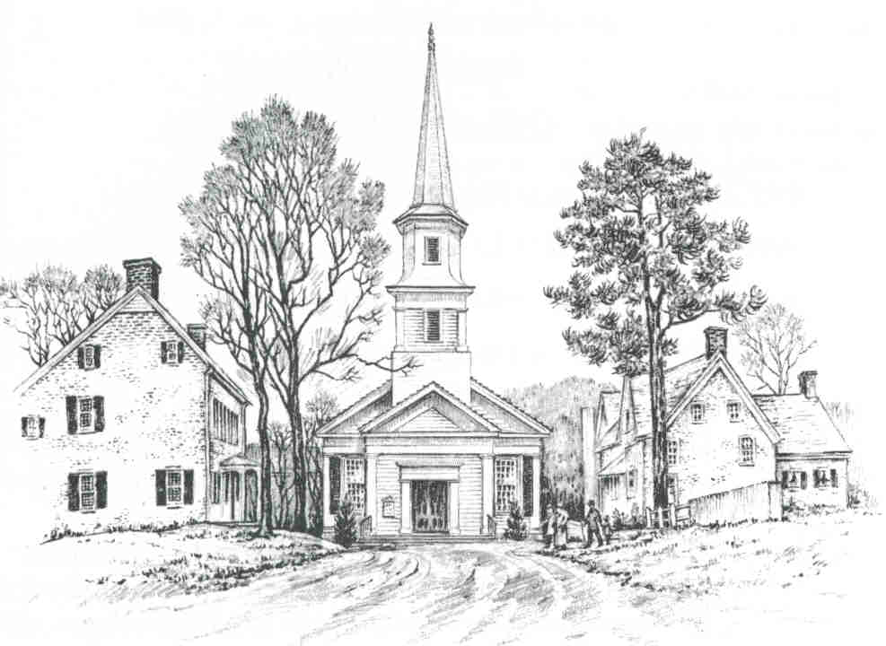

Hurley Reformed Church
Hurley, New York

The Rev. William Appleyard-Pekich
Minister of Word and Sacrament

Welcome
May the doors of this church be wide enough
to receive all who need human love and fellowship, and a Father’s care;
and narrow enough to shut out all envy and hate.

Enter to Worship Depart to Serve

#678 In Christ there is no East or West

1. In Christ there is no east or west,
in him no south or north,
but one great fellowship of love
throughout the whole wide earth.
2. In Him shall true hearts everywhere
their high communion find;
his service is the golden cord
close binding al mankind.
3. Join hands, then, brothers of the faith,
whate'er your race may be!
Who serves my Father as a son Is
surely kin to me.
4. In Christ now meet both east and west;
in him meet south and north,
all Christly souls are one in him
throughout the whole wide earth.

#737 All Things Bright and Beautiful

Refrain:
All things bright and beautiful,
All creatures great and small,
All things wise and wonderful:
The Lord God made them all.

- Each little flow’r that opens,
Each little bird that sings --
He made their glowing colors,
He made their tiny wings.
The purple-headed mountains,
The river running by,
The sunset and the morning
That brightens up the sky.

- The cold wind in the winter,
The pleasant summer sun,
The ripe fruits in the garden now --
He made them every one.
He gave us eyes to see them all,
And lips that we might tell
How great is the Almighty God
Who has made all things well.

THANKSGIVING AFTER COMMUNION
Leader: Brothers and sisters,
since the Lord has now fed us at his Table,
let us praise God’s holy name with heartfelt thanksgiving!
Bless the Lord, O my soul,
People: and all that is within me, bless his holy name.
Leader: Bless the Lord, O my soul,
People: and do not forget all his benefits—
Leader: who forgives all your iniquity,
People: who heals all your diseases,
Leader who redeems your life from the Pit,
People: who crowns you with steadfast love and mercy.
Leader: The Lord is merciful and gracious,
People: slow to anger and abounding in steadfast love.
Leader: He does not deal with us according to our sins,
People: nor repay us according to our iniquities.
Leader: For as the heavens are high above the earth,
People: so great is his steadfast love toward those who fear him;
Leader: as far as the east is from the west,
People: so far does he remove our transgressions from us.
Leader: As a father has compassion for his children,
People: so the Lord has compassion for those who fear him,
Leader: who did not spare his own Son, but gave him up for us all, and
will also give us all things with him.
People: Therefore shall my mouth and heart show forth the praise of
the Lord, from this time forth forevermore. Amen.

#20 Praise to the Lord

Praise to the Lord, the Almighty, the King of creation!
O my soul, praise Him, for He is thy health and salvation!
All ye who hear, now to His temple draw near,
Join me in glad adoration.
Praise to the Lord, who o’er all things so wondrously reigneth,
Shelters thee under His wings, yea, so gently sustaineth!
Hast thou not seen how thy desires e’er have been
Granted in what He ordaineth?
Praise to the Lord, who doth prosper thy work and defend thee!
Surely His goodness and mercy here daily attend thee;
Ponder anew what the Almighty can do
If with His love He befriend thee.
Praise to the Lord, O let all that is in me adore Him!
All that hath life and breath, come now with praises before Him!
Let the amen sound from His people again;
Gladly forever adore Him.

THANKSGIVING AFTER COMMUNION
Leader: Brothers and sisters,
since the Lord has now fed us at his Table,
let us praise God’s holy name with heartfelt thanksgiving!
Bless the Lord, O my soul,
People: and all that is within me, bless his holy name.
Leader: Bless the Lord, O my soul,
People: and do not forget all his benefits—
Leader: who forgives all your iniquity,
People: who heals all your diseases,
Leader who redeems your life from the Pit,
People: who crowns you with steadfast love and mercy.
Leader: The Lord is merciful and gracious,
People: slow to anger and abounding in steadfast love.
Leader: He does not deal with us according to our sins,
People: nor repay us according to our iniquities.
Leader: For as the heavens are high above the earth,
People: so great is his steadfast love toward those who fear him;
Leader: as far as the east is from the west,
People: so far does he remove our transgressions from us.
Leader: As a father has compassion for his children,
People: so the Lord has compassion for those who fear him,
Leader: who did not spare his own Son, but gave him up for us all, and
will also give us all things with him.
People: Therefore shall my mouth and heart show forth the praise of
the Lord, from this time forth forevermore. Amen.

Announcements- September 19, 2021

Barbara Sartorius would love to hear from you as she is adjusting to her new home in New Hampshire!
Barbara Sartorius
c/o The Residence at Silver Square, Apt 306
100 Sterling Way, Dover, NH 03820
Rebecca & Allan Masters have moved! Rebecca retired after 33 ½ years of teaching!
119 Cherry Court
Matamoras, PA 18336
We are looking for volunteers to help some of our members who aren’t able to drive anymore get to worship. If you are willing to assist, not every week but on occasion, please let Rev Bill know.
Recycling Program is Back! Please leave your recyclable cans/bottles in the marked canisters in Schadewald Hall. No need to separate! Terry Grafken will return them and all proceeds will go to the American Cancer Society. Thank you for all your support!
Church Clean Up Day is October 9th, please reach out to Jim Pirro if you can help with anything!
Mark your calendars: October 16th: Craft Fair

THANKSGIVING AFTER COMMUNION
Leader: Brothers and sisters,
since the Lord has now fed us at his Table,
let us praise God’s holy name with heartfelt thanksgiving!
Bless the Lord, O my soul,
People: and all that is within me, bless his holy name.
Leader: Bless the Lord, O my soul,
People: and do not forget all his benefits—
Leader: who forgives all your iniquity,
People: who heals all your diseases,
Leader who redeems your life from the Pit,
People: who crowns you with steadfast love and mercy.
Leader: The Lord is merciful and gracious,
People: slow to anger and abounding in steadfast love.
Leader: He does not deal with us according to our sins,
People: nor repay us according to our iniquities.
Leader: For as the heavens are high above the earth,
People: so great is his steadfast love toward those who fear him;
Leader: as far as the east is from the west,
People: so far does he remove our transgressions from us.
Leader: As a father has compassion for his children,
People: so the Lord has compassion for those who fear him,
Leader: who did not spare his own Son, but gave him up for us all, and
will also give us all things with him.
People: Therefore shall my mouth and heart show forth the praise of
the Lord, from this time forth forevermore. Amen.

Announcements- September 19, 2021

Barbara Sartorius would love to hear from you as she is adjusting to her new home in New Hampshire!
Barbara Sartorius
c/o The Residence at Silver Square, Apt 306
100 Sterling Way, Dover, NH 03820
Rebecca & Allan Masters have moved! Rebecca retired after 33 ½ years of teaching!
119 Cherry Court
Matamoras, PA 18336
We are looking for volunteers to help some of our members who aren’t able to drive anymore get to worship. If you are willing to assist, not every week but on occasion, please let Rev Bill know.
Recycling Program is Back! Please leave your recyclable cans/bottles in the marked canisters in Schadewald Hall. No need to separate! Terry Grafken will return them and all proceeds will go to the American Cancer Society. Thank you for all your support!
Church Clean Up Day is October 9th, please reach out to Jim Pirro if you can help with anything!
Mark your calendars: October 16th: Craft Fair

