A Warm Welcome on this first Sunday of Advent. In this holy season, we remember that God keeps his promises. Rejoice with us
in the covenant of God’s love.
Thank you to Rev. Nick Miles for leading us in worship today.
Greeting you today are Jim and Barbara Mayfield. Ushers assisting in the service are Barbara Kindt and Greg Laib.
The trees are placed on the altar by the Gregory family. As in years past we welcome everyone to take an ornament from the tree. Please see the insert for the legend of the candy cane. Wishing everyone a Blessed Christmas.
There is a Nursery for toddlers and infants in Room 7 and is staffed by an experienced caregiver. If your little one would
rather play or needs a break, please feel free to have them join the fun in the nursey. The service is piped in and you are welcome to stay with your child.
Join us in Schadewald Hall after worship for fellowship with refreshments
provided by Su Wonderley and Niki Provenzano. We love all goodies –homemade or store bought. Please sign up for refreshments for fellowship hour. There is a signup sheet posted in Schadewald Hall. DATES ARE AVAILABLE.

ANNOUNCEMENTS FOR December 3, 2017
Activities this week:
Sunday: 11:15 Women’s Ministries
Tuesday: 11:00 am Balance for Life class
Wednesday: 7:30 am Bible Study
Thursday: 9:30 am Badminton
7:00 pm Choir Rehearsal
Saturday: Cookie Walk Set up

Poinsettia Orders are due today. Please give your order to Kathy Jansen.
Soup is available during fellowship hour. It’s minestrone soup.
The Pecans have arrived! See Sandy Emrich.
Bakers and cookie makers! Sign up to participate in the cookie walk on December 10. See Sandy Emrich during fellowship.
Envelopes for 2018 are available in Schadewald Hall.
Wednesday Morning Bible Study We are looking at the Psalms and we invite you to join us. Bring your Bibles and take a journey with us and David at 7:30 am. Have some coffee and goodies and enjoy the time of fellowship with Rev. Stickley and the group. Love to see you there.....Rev
Special Parsonage Renovation Fundraiser 2017: A number of renovation projects have been or will be undertaken at the parsonage. These projects include refinishing the living and dining room wood floors, replacement of flooring in the upstairs hallway, master bedroom, laundry and rear sun rooms, carpeting on stairs, re-pointing of all three chimneys, plumbing repairs, roof repair and painting. The total cost for these projects is estimated to exceed $10,000. In an effort not to deplete the Church’s saving account, we are initiating a special parsonage renovation fundraising program. We ask for your support in this endeavor by identifying your donations as “Parsonage Renovation Project.” Thank you again for your generous support.
An Open House will take place during fellowship hour on December 17 so everyone can see the renovations.
The Giving Tree is up & full of tags for you to pick & purchase the item(s) on the tag & return them unwrapped to the tree on or before December 10. This year we have adopted 5 families plus will be helping out Meyer School nurse in the needs that come into her office. A wrapping gathering will be held after church on Dec 17. Please bring your scissors, scotch tape & let Lisa Longto that you will be able to help out. If you have any questions please see Lisa Longto or Sandy Emrich. Thank you for support!!
Congratulations! New Consistory Members have been approved by the Congregation. James Pirro and Sandra Gregory will be installed as Elders; Chris Decker, Sandra Emrich and Roberta Falatyn will be installed as Deacons. If anyone knows of any legitimate objections they should contact a member of the Board of Elders. Installation will be January 7, 2018.

Minister for December 10: Rev Nick Miles; for December 17, 24 and 31 and Christmas Eve Services and January 7: Rev. Charles Stickley.
During this time frame without an onsite minister, Reverends Titus (Red Hook), and Van Houten (Fair St.) as well as Rev. Stickley have offered their services to provide pastoral care (home/nursing home/hospital visitations) or any other ministerial needs of our congregation. If you are in need of such care, please contact Dennis Croswell (331-5944), Dorothy at the church office (331-4121) or the Deacon of the month as listed in the weekly bulletin.
Mission of the month: Last week the Mission committee went shopping to buy warm clothes, etc. for the Clinton Ave Warming Center. With a limited selection to choose from, we decided to donate the remainder of the $500 collected to the center itself to buy what is needed. December’s mission collection will be for Family of Woodstock.
Jay Marrus and family thank the Hurley Reformed Church family for all the cards and expressions of sympathy.
Thank you to all my friends and fellow choir members for provided good thoughts, encouragement, prayers and food during my convalescence. -- Helen Sgroi.
Deacon of the month is Dino Sumerano. Call Dino at 845-331-4217 if you need a deacon’s assistance.

The Reformed Church is a connectional church. Our classis includes 33 congregations in the Mid-Hudson Valley. We pray for the strength and vision of the pastors and the revitalization of their members. Today we pray for the New Paltz Reformed Church in New Paltz, New York.

Dec. 16, 2017
9 am – 11 noon
Schadewald Hall
Reservations Needed
Call the Church Office 331-4121

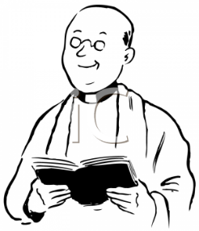
Minister Update:
Our candidate Rev. William Appleyard-Pekich will preach before our congregation on January 14, 2018 and a congregational meeting will be held immediately after service to determine the congregation's desired direction for the Consistory. Informal meetings with the various organizations within the church and the candidate will be held on Saturday prior to the service to provide an opportunity for members to meet him and his family and to ask questions. A signup sheet is in Schadewald Hall. See Doug Constant to sign up.
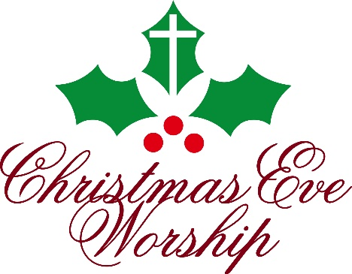

O Come, Let Us Adore Him

You and Your family are invited to join us to celebrate the birth of Jesus Christ in our Christmas Eve Services:
7:00pm - A service of Carols and Candles to welcome the Light that comes in the Christ Child
9:00pm - We celebrate His birth with a service of Carols, Candles, and Celebration of the Lord’s Supper
Experience the Wonder in the beauty of the season
as we join together in the sanctuary to welcome Him
as the Babe of Bethlehem who comes to give us joy and
peace, this night and all year long.

