ANNOUNCEMENTS FOR December 17, 2017
Activities this week:
Sunday: After worship: Church School Pageant
After worship: Parsonage Open House
Tuesday: 11:00 am Balance for Life class
Wednesday: 7:30 am Bible Study
Thursday: 9:30 am Badminton
7:00 pm Choir Rehearsal

A Warm Welcome on this third Sunday of Advent. In this holy season, we remember that God keeps his promises. Rejoice with us in the covenant of God’s love.
Thank you to Rev. Stickley for leading us in worship today.
Greeting you today are Patti Gilpatric and Linda Moon. Ushers assisting in the service are Sandra Gregory and Kathy Jansen.
There is a Nursery for toddlers and infants in Room 7 and is staffed by an experienced caregiver. If your little one would rather play or needs a break, please feel free to have them join the fun in the nursey. The service is piped in and you are welcome to stay with your child.
Join us at the Parsonage after the Christmas Pageant for fellowship with refreshments provided by Rev. and Mrs. Stickley. This gives you the opportunity to see the work done on the parsonage in anticipation of the new pastor.
We love all goodies –homemade or store bought. Please sign up for refreshments for fellowship hour. There is a signup sheet posted in Schadewald Hall. DATES ARE AVAILABLE.
Sunday School is presenting the annual Christmas Pageant on December 17 following the church service.
Envelopes for 2018 are available in Schadewald Hall. If you currently don’t have an assigned envelope and want one, see Dennis Croswell or Jim Craven.
Articles for the Spire are due this week.
Thank you to everyone who helped decorate the Church for the season – Doris
Thank you to everyone who helped make Breakfast with Santa a great success.
Wednesday Morning Bible Study: Morning Bible Study is looking at the birth of Jesus in the four accounts of the Gospels for the next weeks. You can join us at 7:30 for fellowship: some goodies: coffee and a look at the gift of the Manger... We can even find a Bible for you.....Join us! REV
Congratulations! New Consistory Members have been approved by the Congregation. James Pirro and Sandra Gregory will be installed as Elders; Chris Decker, Sandra Emrich and Roberta Falatyn will be installed as Deacons. If anyone knows of any legitimate objections they should contact a member of the Board of Elders. Installation will be January 7, 2018.
Prayer Request. Mimi Croswell had surgery on her shoulder on Friday. Prayers are requested for quick healing.
Deacon of the month is Dino Sumerano. Call Dino at 845-331-4217 if you need a deacon’s assistance.
Lorraine Denis fell, broke her shoulder, had surgery and is in rehab for the next eight weeks. She wants everyone she sends cards to that she won’t be doing that for a while and hopes they understand.
Mission of the month: Last week the Mission committee went shopping to buy warm clothes, etc. for the Clinton Ave Warming Center. With a limited selection to choose from, we decided to donate the remainder of the $500 collected to the center itself to buy what is needed. December’s mission collection will be for Family of Woodstock.
The Reformed Church is a connectional church. Our classis includes 33 congregations in the Mid-Hudson Valley. We pray for the strength and vision of the pastors and the revitalization of their members. Today we pray for Shandaken Reformed Church, Mt. Tremper, New York.

Special Parsonage Renovation Fundraiser 2017: As the transition team/search committee continues the process* and in an effort to attract a new “call” minister, a number of renovation projects have been or will be undertaken at the parsonage. These projects include refinishing the living and dining room wood floors, replacement of flooring in the upstairs hallway, master bedroom, laundry and rear sun rooms, carpeting on stairs, re-pointing of all three chimneys, plumbing repairs, roof repair and painting. The total cost for these projects is estimated to exceed $10,000. In an effort not to deplete the Church’s saving account, we are initiating a special parsonage renovation fundraising program. We ask for your support in this endeavor by identifying your donations as “Parsonage Renovation Project.” Thank you again for your generous support.
Minister for December 24 and 31 and Christmas Eve Services and January 7: Rev. Charles Stickley.
During this time frame without an onsite minister, Reverends Titus (Red Hook), and Van Houten (Fair St.) as well as Rev. Stickley have offered their services to provide pastoral care (home/nursing home/hospital visitations) or any other ministerial needs of our congregation. If you are in need of such care, please contact Dennis Croswell (331-5944), Dorothy at the church office (331-4121) or the Deacon of the month as listed in the weekly bulletin.

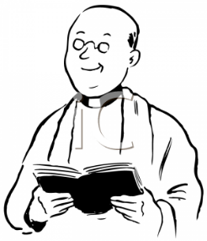
Minister Update:
Our candidate Rev. William Appleyard-Pekich will preach before our congregation on January 14, 2018 and a congregational meeting will be held immediately after service to determine the congregation's desired direction for the Consistory. Informal meetings with the various organizations within the church and the candidate will be held on Saturday prior to the service to provide an opportunity for members to meet him and his family and to ask questions. A signup sheet is in Schadewald Hall. See Doug Constant to sign up.

Reach out to those who need your support in their day today needs:
Shirley Ruth is in Mountain View Manor; Helen Sgroi is home; Bud Dussol at Golden HIll; Don Kent at the Terraces at Brookmeade; Betty Pirro, Bev Chrisey, Friedel Borst, Audrey Hornbeck and Fred Horvers at TenBroeck; Wayne Waligurski, Charlotte Gill, Tony Peralta (Julie Provenzano’s son-in-law), Esther Keator; Dolores McGoldrick at Ferncliff; Lori Pinkham in Wingate at Ulster, Peter Jackson from Hurley, England, William Wiacek (Cathy McGraw’s brother), Bill Gogg is home.
Office hours are 8:30-12:30 weekdays except Mondays.
Large Print hymnals and bulletins are available in the narthex.
Hearing Assistance is Available: Hearing assistance units are now available
in the narthex. See an usher for assistance.
Bulletin Announcements on line: Check out the announcements from this
week’s bulletin on the church’s website! Go to the church’s website hurleyreformedchurch.org. Click on calendars under website navigation (on left side of page). They are listed in reverse date order (most recent first).
Audio recordings of the weekly sermon are available on our website,
HurleyReformedChurch.org and on CDs which are on the table in the narthex
______________________________________________________

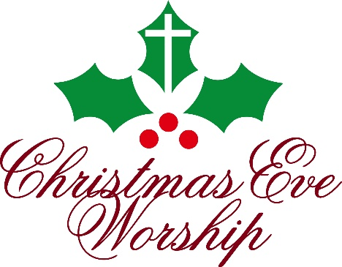

O Come, Let Us Adore Him
You and Your family are invited to join us to celebrate the birth of Jesus Christ in our Christmas Eve Services:

7:00pm - A service of Carols and Candles to welcome the Light that comes in the Christ Child
9:00pm - We celebrate His birth with a service of Carols, Candles, and Celebration of the Lord’s Supper
Experience the Wonder in the beauty of the season
as we join together in the sanctuary to welcome Him
as the Babe of Bethlehem who comes to give us joy and
peace, this night and all year long.

