A Warm Welcome on this second Sunday of Advent. In this holy season, we remember that God keeps his promises. Rejoice with
us in the covenant of God’s love.
Thank you to Rev. Nick Miles for leading us in worship today.
Greeting you today are Su and Drew Wonderly. Ushers assisting in the service are Dino Sumerano and Jim Craven.
Altar flowers are placed by Wally and Linda Cook in honor of our children and grandchildren and in memory of our parents.
There is a Nursery for toddlers and infants in Room 7 and is staffed by an experienced caregiver. If your little one would
rather play or needs a break, please feel free to have them join the fun in the nursey. The service is piped in and you are welcome to stay with your child.
Join us in Schadewald Hall after worship for fellowship with refreshments. We love all goodies –homemade or store
bought. Please sign up for refreshments for fellowship hour. There is a signup sheet posted in Schadewald Hall. DATES ARE AVAILABLE.
ANNOUNCEMENTS FOR December 10, 2017
Activities this week:
Sunday: Cookie Walk
Tuesday: 11:00 am Balance for Life class
Wednesday: 7:30 am Bible Study
Thursday: 9:30 am Badminton
7:00 pm Choir Rehearsal
Saturday 9:00 am Breakfast with Santa
The annual Cookie Walk will be held during coffee hour. Cookies will be $6 per pound. Grab a box & fill it up with your
delicious cookies made by local bakers(the women & men of the church). Get your favorite cookies before they are all gone. Thanks for support the Women's Guild.
This is the last day for Women's Guild annual pecan sales. They have been reduced to $8 per bag. We have plain, dark
chocolate & cluster pecan available. Get yours before they are all gone. Thanks for your support.
Sunday School is presenting the annual Christmas Pageant on December 17
following the church service.
Envelopes for 2018 are available in Schadewald Hall. If you currently don’t have an assigned envelope and want one, see
Dennis Croswell or Jim Craven.
Wednesday Morning Bible Study: Morning Bible Study is looking at the birth of Jesus in the four accounts of the Gospels for the
next weeks. You can join us at 7:30 for fellowship: some goodies: coffee and a look at the gift of the Manger... We can even find a Bible for you.....Join us! REV
Special Parsonage Renovation Fundraiser 2017: A number of renovation projects have been or will be undertaken at the
parsonage. These projects include refinishing the living and dining room wood floors, replacement of flooring in the upstairs hallway, master bedroom, laundry and rear sun rooms, carpeting on stairs, re-pointing of all three chimneys, plumbing repairs, roof repair and painting. The total cost for these projects is estimated to exceed $10,000. In an effort not to deplete the Church’s saving account, we are initiating a special parsonage renovation fundraising program. We ask for your support in this endeavor by identifying your donations as “Parsonage Renovation Project.” Thank you again for your generous support.
An Open House at the Parsonage will take place during fellowship hour on December 17 so everyone can see the renovations.
The Giving Tree is up & full of tags for you to pick & purchase the item(s) on the tag & return them unwrapped to the tree on or
before December 10. This year we have adopted 5 families plus will be helping out Meyer School nurse in the needs that come into her office. A wrapping gathering will be held after church on Dec 17. Please bring your scissors, scotch tape & let Lisa Longto that you will be able to help out. If you have any questions please see Lisa Longto or Sandy Emrich. Thank you for support.
Congratulations! New Consistory Members have been approved by the Congregation. James Pirro and Sandra Gregory will
be installed as Elders; Chris Decker, Sandra Emrich and Roberta Falatyn will be installed as Deacons. If anyone knows of any legitimate objections they should contact a member of the Board of Elders. Installation will be January 7, 2018.
Minister for December 17, 24 and 31 and Christmas Eve Services and January 7: Rev. Charles Stickley.
During this time frame without an onsite minister, Reverends Titus (Red Hook), and Van Houten (Fair St.) as well as Rev. Stickley have offered their services to provide pastoral care (home/nursing home/hospital visitations) or any other ministerial needs of our congregation. If you are in need of such care, please contact Dennis Croswell (331-5944), Dorothy at the church office (331-4121) or the Deacon of the month as listed in the weekly bulletin.
Mission of the month: Last week the Mission committee went shopping to buy warm clothes, etc. for the Clinton Ave Warming
Center. With a limited selection to choose from, we decided to donate the remainder of the $500 collected to the center itself to buy what is needed. December’s mission collection will be for Family of Woodstock.
Deacon of the month is Dino Sumerano. Call Dino at 845-331-4217 if you need a deacon’s assistance.
The Reformed Church is a connectional church. Our classis includes 33
congregations in the Mid-Hudson Valley. We pray for the strength and vision of the pastors and the revitalization of their members. Today we pray for the New Hackensack Reformed Church, Wappingers Falls, New York.

Dec. 16, 2017
9 am – 11 noon
Schadewald Hall
Reservations Needed
Call the Church Office 331-4121

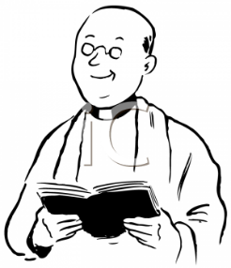
Minister Update:
Our candidate Rev. William Appleyard-Pekich will preach before our congregation on January 14, 2018 and a congregational meeting will be held immediately after service to determine the congregation's desired direction for the Consistory. Informal meetings with the various organizations within the church and the candidate will be held on Saturday prior to the service to provide an opportunity for members to meet him and his family and to ask questions. A signup sheet is in Schadewald Hall. See Doug Constant to sign up.
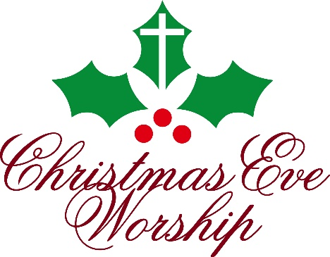

O Come, Let Us Adore Him

You and Your family are invited to join us to celebrate the birth of Jesus Christ in our Christmas Eve Services:
7:00pm - A service of Carols and Candles to welcome the Light that comes in the Christ Child
9:00pm - We celebrate His birth with a service of Carols, Candles, and Celebration of the Lord’s Supper
Experience the Wonder in the beauty of the season
as we join together in the sanctuary to welcome Him
as the Babe of Bethlehem who comes to give us joy and
peace, this night and all year long.

